Assignment 1- Android

On invocation, the app displays list of choices to user. Selecting BMI, BMI window displayed. Entering in height and weight in the respective edit controls and clicking calculate button, BMI computed. Dialog informs user if overweight or underweight. User has option to return to main menu or continue.

App is configured for horizontal and vertical layout. Also has custom icon and graphic displayed on BMI window.

I had begun to setup Preference Activities for defaults/new values – it’s commented out in the code and not visible in the Manifest. State is also preserved when app placed in background by android – onSaveInstanceState being the great ‘catch all.’

App localized to French for main BMI window and the enter weight and height displays. I also verified that it works horizontally using Genymotion.

The application is driven by Activities and as such each class implementation is independent, save for height/weight variables passed from respective windows with intents (configured in Manifest file) between activities.

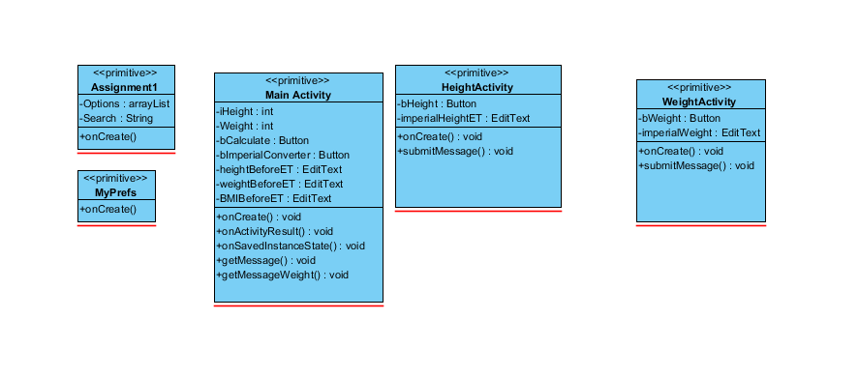

Custom icon created.

1. 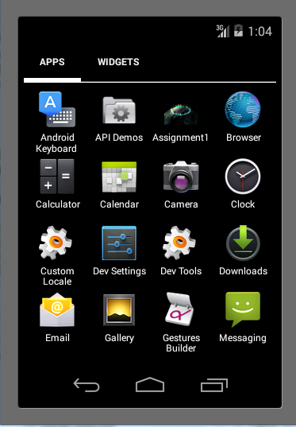

User presented with list of options on entry.

1. 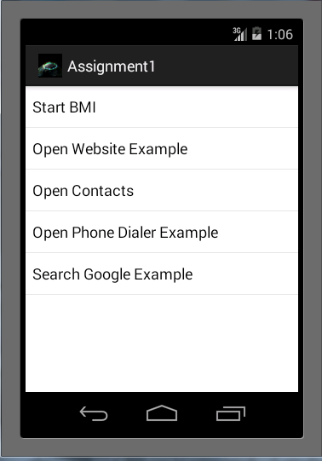

Main App-

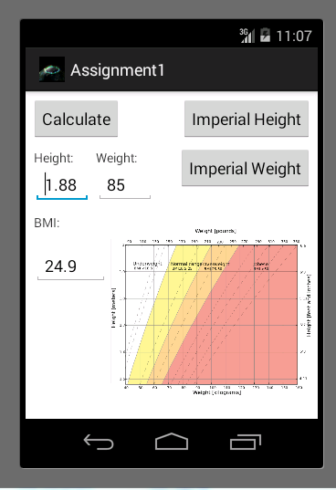

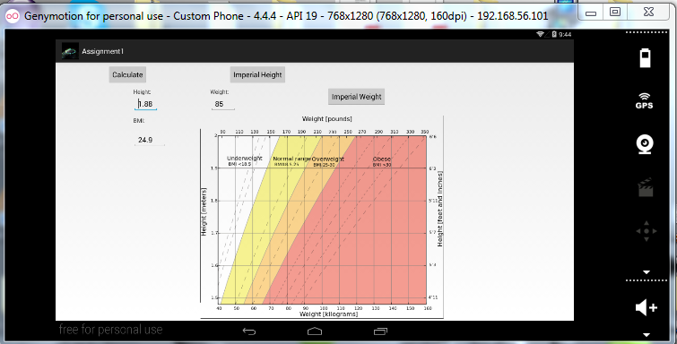

I have a few spacers in the layout-land XML file where I can right-adjust the ‘Imperial Weight’ and ‘Imperial Height’.

1. User after calculating BMI, offers advice whether to gain/lose weight and presented with options of continuing or returning to main menu….

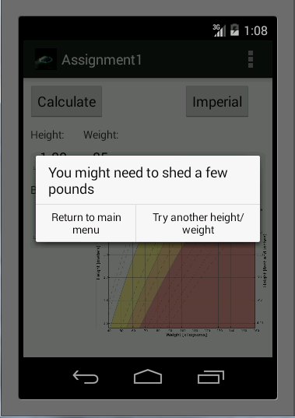

Clicking the Imperial HeightButton-

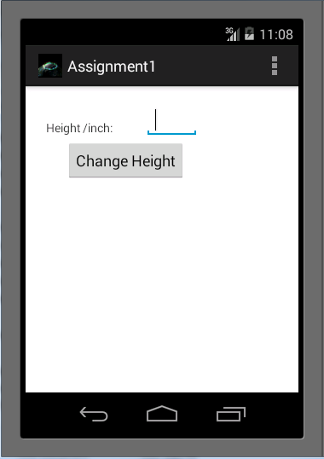

Clicking the Imperial Weight Button

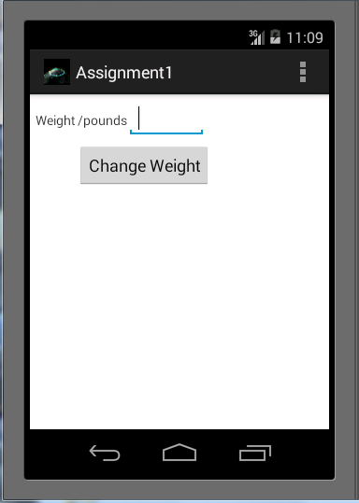

Localization-

The main window(and the enter weight/height) is localized to French.

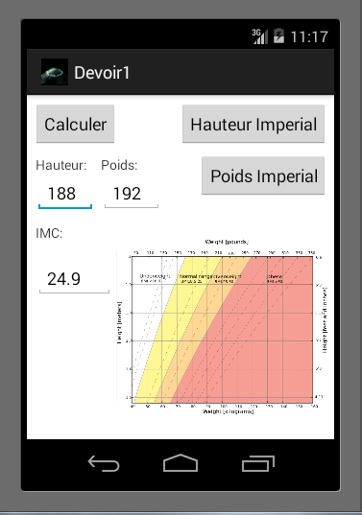

Features of the app not working-

1. I’ve only used the imperial buttons to demonstrate message passing.
2. Not enough time to finish saving preferences – code commentated out

Future outlook-

The emulator is very slow and cumbersome. Genymotion is a more productive environment. This was a learning experience for me. I suppose being a light-weight calculation there was no need for an anonymous function to calculate the BMI. I could have simply used message passing and the onClick attribute for the button in the XML and sub classing. I simply did not know this.

1. Finish the preferences settings .
2. Localize other hard-coded main menu